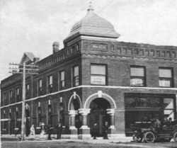
Deann Williams, Mayor
Donna J. Warren, City Clerk
Todd Luckman, City Attorney
Blaine A. Carter,
Municipal Judge

City of Eskridge
110 S. Main Street/P.O. Box 156
Eskridge, KS 66423
Phone (785)449-2621
Fax (785)449-7289

Eskridge City Council: Tami Bagley Brett Kemble Cindy Kraus Justin Rush Tim Wines

September 26, 2017

To The KCC Utility Customers:

Attached please find a copy of the Cold Weather Rule, which was written by the Kansas Corporation Commission.

If you have any questions concerning the Cold Weather Rule, or if you need to resolve a problem please contact our office at:

City of Eskridge
110 S. Main Street
P.O. Box 156
Eskridge, KS 66423
Telephone: 785-449-2621
Email: Clerk@eskridgeks.org
Website: http://www.eskridgeks.org/home/utilities/

You may also contact:

Kansas Corporation Commission
1500 SW Arrowhead Road
Topeka, KS 66604-4027
Telephone: 800-662-0027

Normal business hours are Monday through Friday from 8:00 a.m. to 4:30 p.m.
Authorized payments can be made in person at the address shown above. Cash, personal checks, money orders and automatic bank drafts are accepted.

Payments can be mailed to the City of Eskridge, P.O. Box 156, Eskridge, KS 66423. You should allow sufficient time for your payment, if mailed to reach our office by its due date. Normally, we suggest that you allow at least five (5) business days for your payment to be received.

Please contact our office if you have questions or if we can be of service.

Sincerely,
Donna Warren
City Clerk

